Discover Associations Between Products

Main goal:

Make a customer profile and a product profile from Electronidex that will tell us if Blackwell should acquire Electronidex.

After conducting a market basket analysis we saw that Electronidex has much less concentrated product portfolio but show strength on their top products like Laptops and Desktops. Blackwell could benefit thanks to the huge profitability of Product Warranties.

Also most of Electronidex products directed towards customers will likely lead on the purchase of Blackwells accesories. **Therefore, our recommendation is that Electronidex should be adquired by Blackwell**

_________________________________________________________________________________________________________________________

Conducting a **market basket analysis by** identify purchasing patterns that will provide insight into Electronidex's clientele.

Our inital approach was to split the data in two types: **by single costumers and bussineses. We will consider bussines the transactions which purchase:**

* More than 6 Items
* More than 3 laptops
* More than 2 desktops
* More than 2 printers
* More than 3 monito

Applying this pre-processing we splitted the data in two datasets that are:



74.45%

25.5%

With the data given by Electronidex we can have a customer profile and Product profile

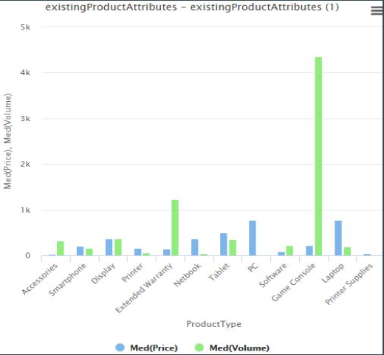**For reference we include Blackwells item type frequency**

Game Consoles and Extended warranty are Blackwells top sold products.

Printer and printer supplies are the least sold products.

Electronidex Product Profile:

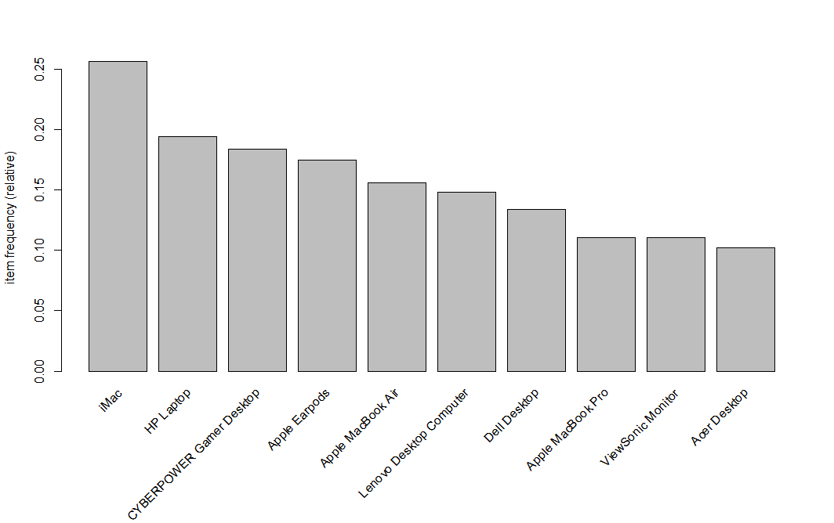Electronidex top sold items are mostly Laptops and Desktops. **iMac and HP laptops** are the top 2 sold products which presumably have higher profit margin

Electronidex has much less concentrated product portfolio.

Electronidex Customer Profile:

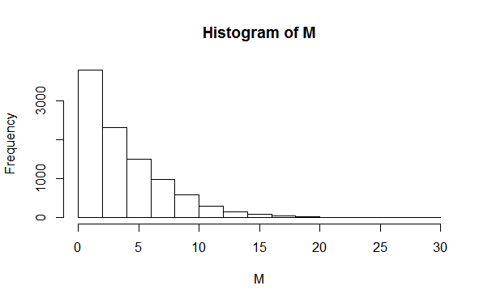Two types of customers : single costumers and bussineses. Mostly single customers.

Most of transactions have less than 5 items

We can see that consumers on Electronidex who bought iMac at least bought one other product. **This implies that selling iMac on the catalog will increase the likelihood of buying more items.**

**The exact same thing happens with HP Laptop.**

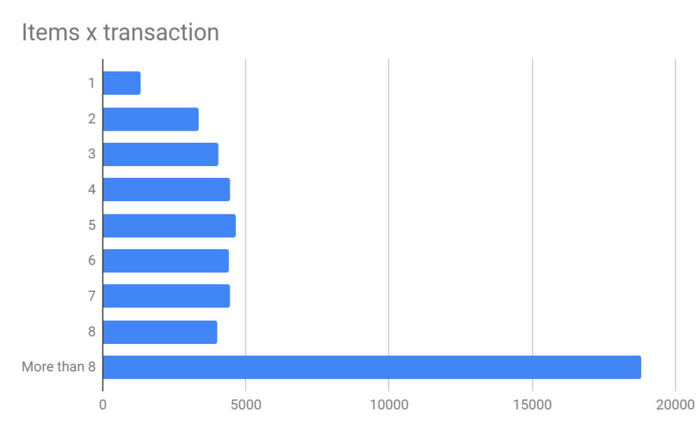

Having bought iMac

Electronidex Product Associations

After splitting up the data between Customers and Bussines we can start evaluating the product associations. We associated every Electronidex product into a category which Backwell

By product type :

**Electronidex to Customers:**

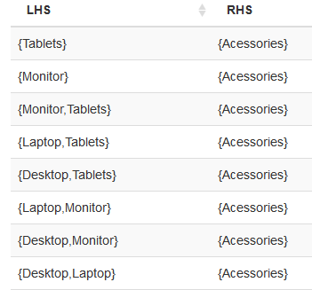

As we can see, with single Customer transactions we recive the strongest associations with **Acesories.**

**Electronidex to Businesses** :

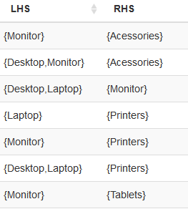

The strongest associations for bussineses involve Printers and Acessories.

By specific product:

**Electronidex to Customers:**

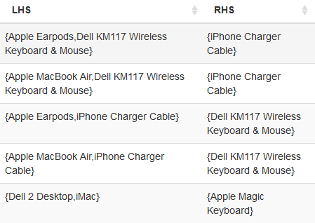

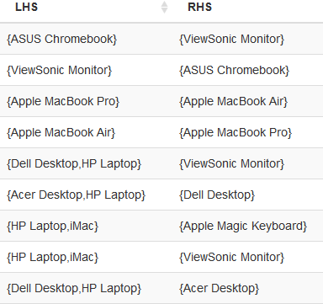**Electronidex to Businesses** :

Insights on adquiring Electronidex:

The strongest product associations for bussineses involve Printers. **Blackwells volume of sales for these type of products are the weakest, therefore if we were to aquire Electronidex we should take the chance to improve the promotion of printers selling.**

A customer buying one of Electronidex’s Monitors or Laptops will likely also buy more accesories, it is a good oportunity to **merge Electronidex main products (Laptops or Monitors) with Blackwells accessories** (offering packs or bundles).

Blackwell’s warranties is one of the most profitable product, we could **combine them with high demanded products like HP Laptops or iMac** (products which are not on the current product catalog of Blackwell).

More variables like *Item profitability* and *time frame the data has been gathered* would be useful to give a deeper insight.